**29-MAR-2019**

Windows =🡺 Windows (RDP) :3389 Protocol

Remote Desktop Access

Windows=🡺 Linux 22 (SSH)

EC2 Instance is IAAS service.(Infra Structure as Service)

30-Mar-2019

* Amazon linux (Free Tier) 2018.03.0 -SSD Volume Type

(64 bit operating x 86)

Linux storage 8 GB select

To Linux server port number is 22

EC2 Metadata Information about my EC2 Instance URL

<http://169.254.169.254/latestversiontypein>

Two Type of Ami

1. Base Ami/Golden Ami
2. Backup Ami

Base Ami used to create different types of Instances or servers for different users or Groups

Backup Ami used to create Backup of your c drive and d drive

Base Ami/Golden Ami =🡺

C://Amazon Folder =🡺 EC2 Config Service🡺 settings🡺 confix.xml

Change EC2SetPassword and EC2Inilize Drive.

03-April-2019 Notes

1. AWS supports only Round Robin Technology for Load Balancer
2. Distributing the requests in load balancer
3. There are two kinds of web applications

Stateless Application , Stateful Application

11-April-2019 Notes

Three types of load balancer

1. Application Load Balancer
2. Network Load Balancer
3. Classic Load Balancer

Application Load Balancer maintains the Target Group.

At an application level maintains the Target Group

Classic Load Balancer will get get deprecated slowly

Application Load Balancer -Layer 7

Network load Balancer – 4 (TCP Port ) Based on the Port it will distribute the load

S3 Instance Notes

File is nothing but DataObject in AWS.

Parent Folder is nothing but S3 Bucket in AWS.

Bucket – Static Name – Unique in the world

Size of the bucket – Infinite storage.

S3- AWS Region Based.

Manually to upload Data Object in AWS is 5TB (Single Size File)

Using Automation to upload DataObject is Max size is 5 GB Using PUT Object api .

Folder Path is called Key in AWS. (Object URL)

Data Objects transfer will happen using Internet in small Chunks(Data Packets)

Etag of DataObject will maintain security of the Object in AWS

For checking any suspiuous attacking

Using MD5 Check Sum Online we can check for the Security of the Object

Object Encryption are two types

1. Server-Side Encryption
2. Client-Side Encryption

S3- Blob Storage (24,7,365) It runs

S3-Instance is storage

S3- Simple Storage Service

**09-april-2019 Notes**

SNS (Simple Notification Service)

User – User subscription for single entity

Group – SNS Topic for Group of entities

**26-MAR-2019 Notes**

Elastic cloud computing

EC2 Instance

VMWare – Virtual Servers (2000,1998)

AMI (Amazon Machine Image) , EC2 Instance you can create from an existing AMI

MY AMI to Market – use AWS Market Place

**30-MAR-2019 Notes**

* Information about MetaData for an EC2 Instance you can use this below URL , to get the information , This URL should be typed in newly launched EC2 Instance.

http://169.254.169.254/latest/meta-data/

ami-id

ami-launch-index

ami-manifest-path`

block-device-mapping/

events/

hostname

identity-credentials/

instance-action

instance-id

instance-type

local-hostname

local-ipv4

mac

metrics/

network/

placement/

profile

public-hostname

public-ipv4

public-keys/

reservation-id

security-groups

services/

* AMI (Amazon Image )
* AMI Based on Region
* Two Types of AMI’s

1. Base AMI/Golden Ami
2. Backup AMI

* EC2 Config Service in newly launched EC2 Instance

C:\\Amazon Folder 🡺 EC2 Config Service🡪Settings.xml,Config.xml change the

**20-april-2019 Notes**

**Identity Access and Management (IAM Roles)**

* Our email Account Id is Root Login (System Admin)
* Users/Roles to me maintained with IAM.
* Child users access restricted by Root User (Super Admin)
* S-3 Object can be controlled

<https://972102700985.signin.aws.amazon.com/console> - MY IAM URL (customize url) By giving unique account alias for my account Id.

IAM 🡪 Add User Scree shot1

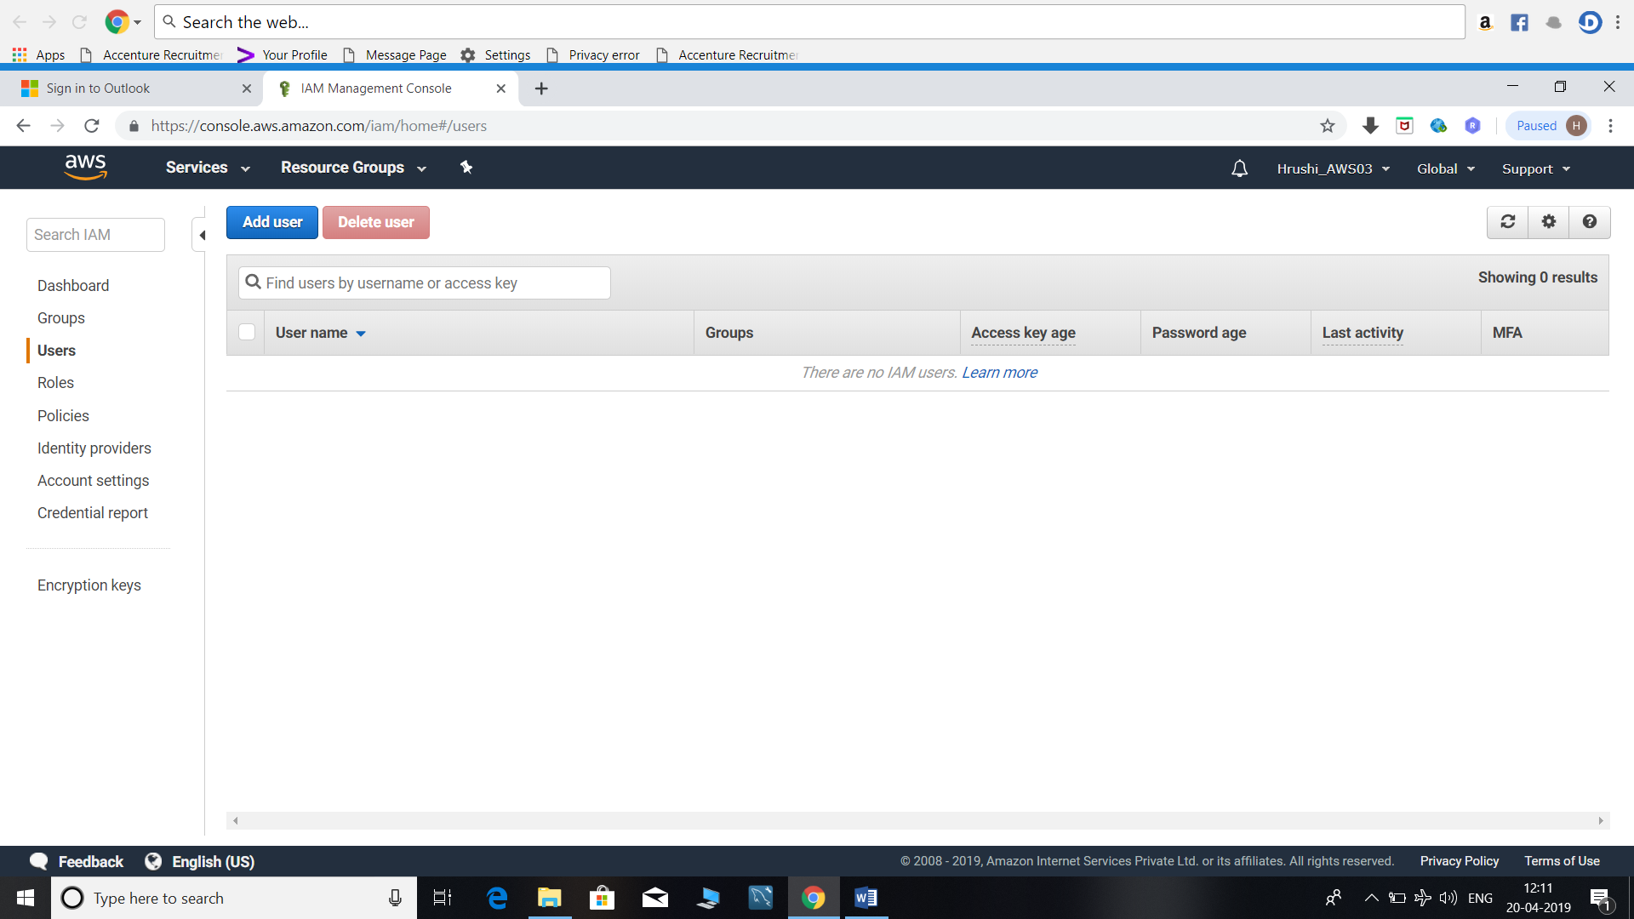

Add User Screen shot2

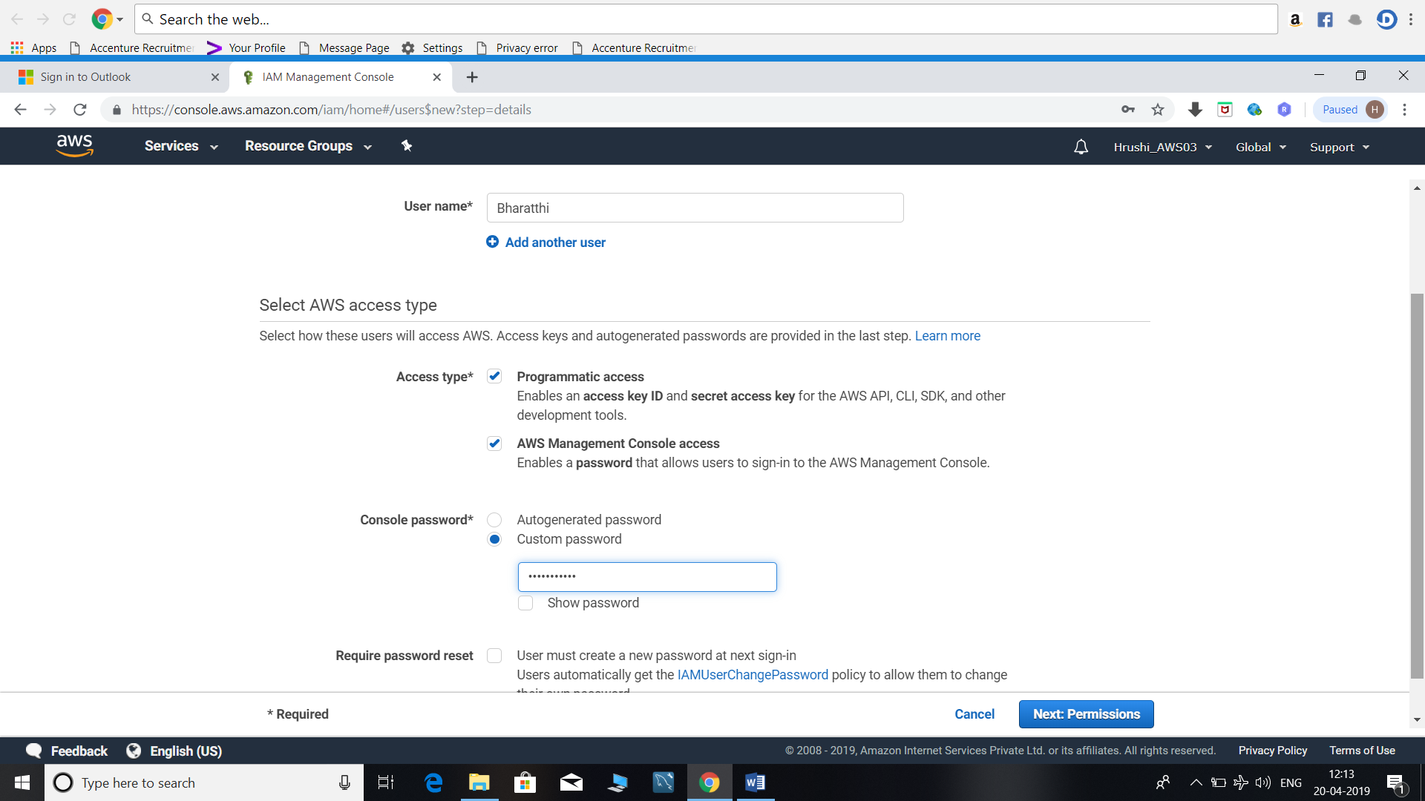

Add User 3 screen shot

Using Multi Factor Authentication (MAF) Screen – you can use any app Google authenticator to get the mobile one time password .

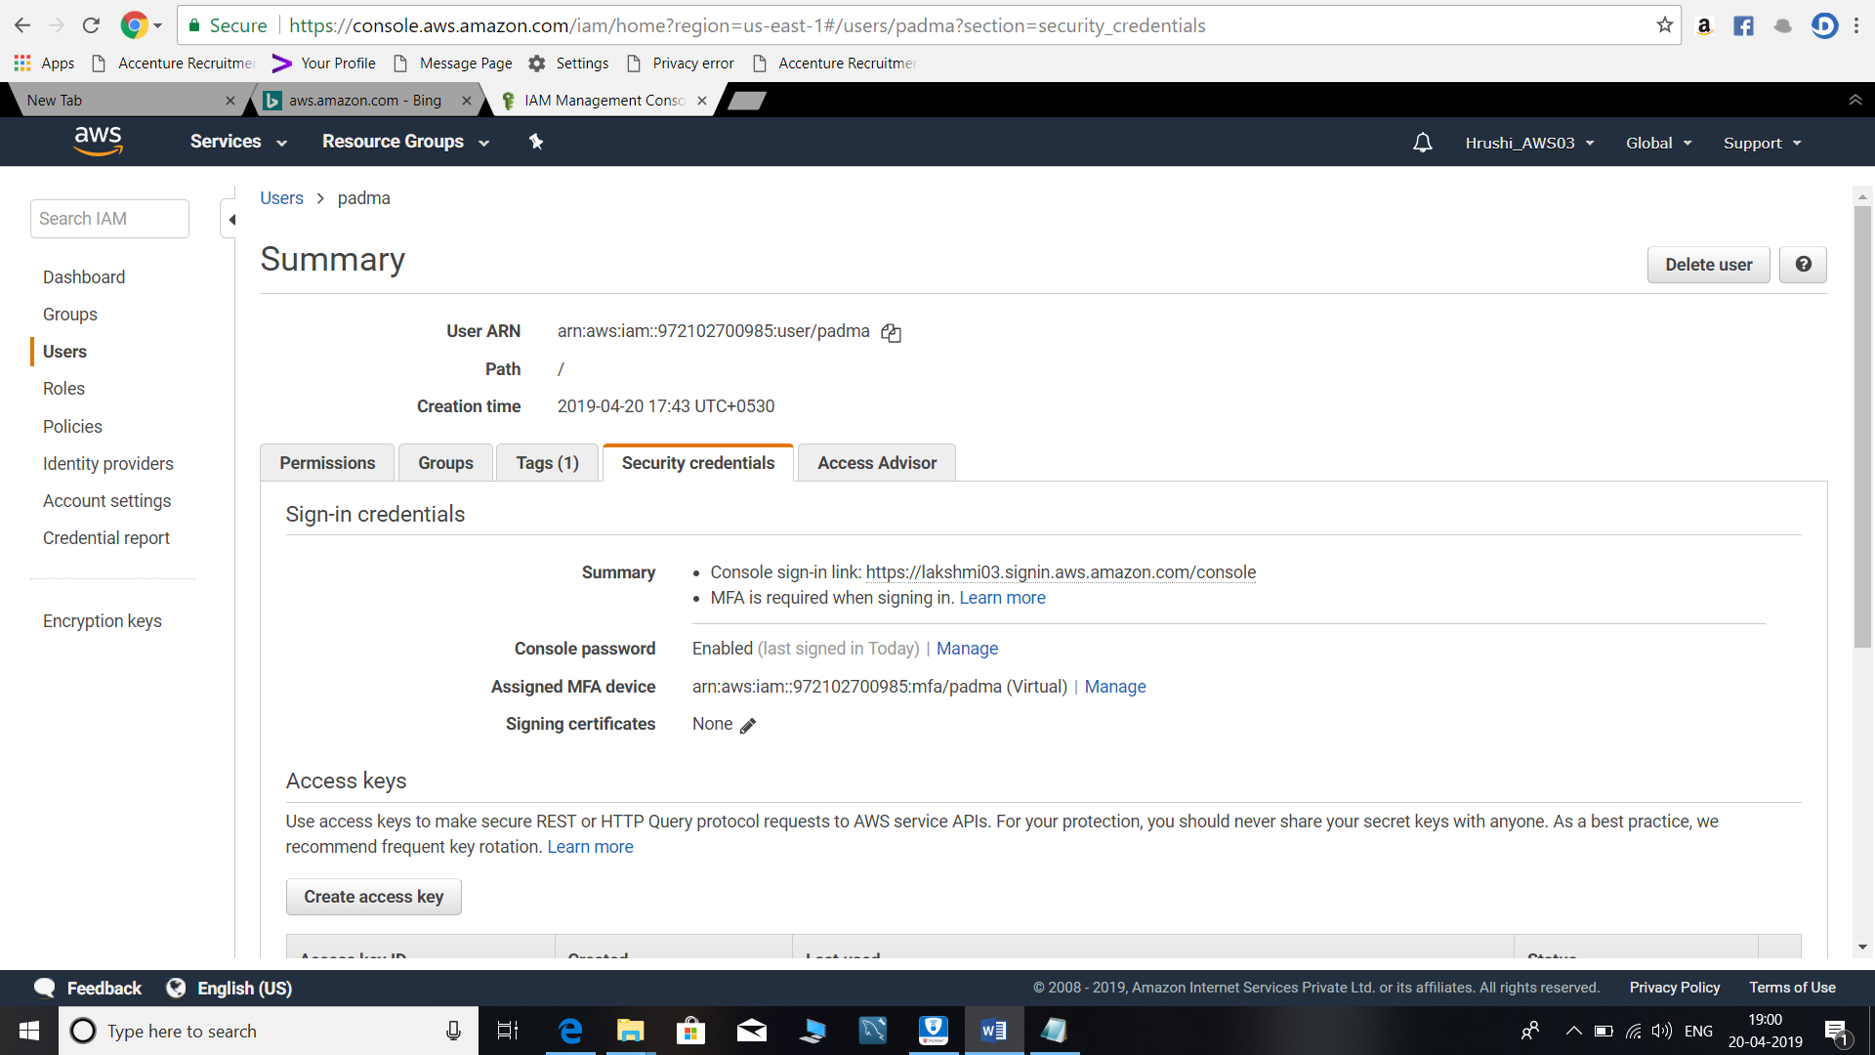

User Added to the group screen

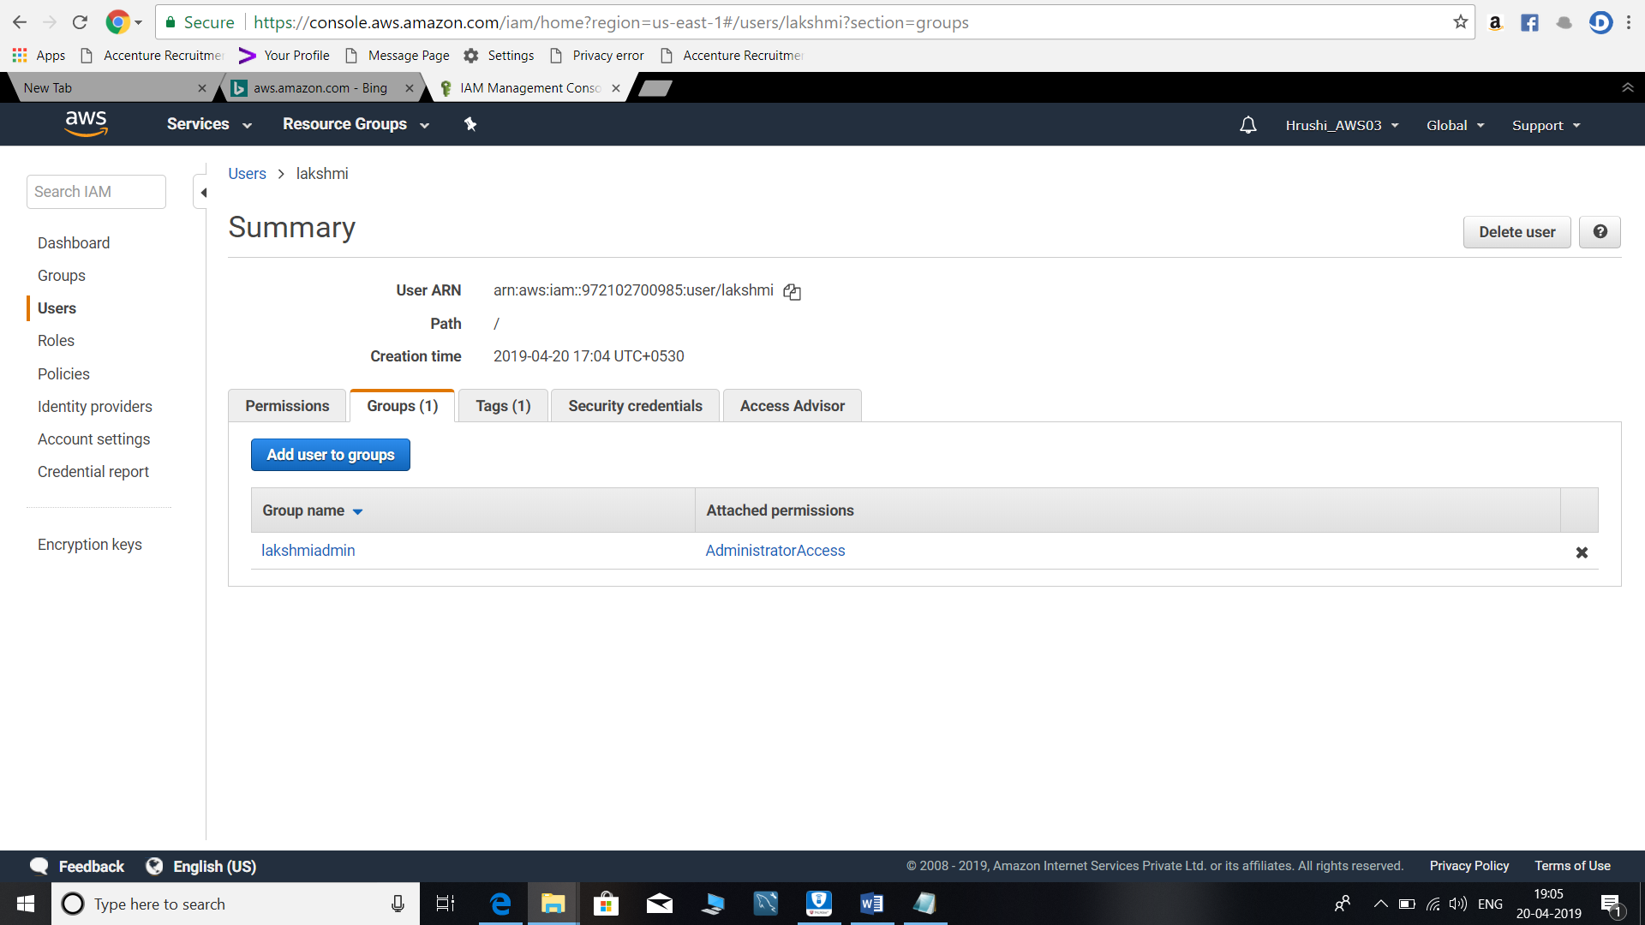

**AWS CLI Notes: 19-april 2019 Notes**

<https://aws.amazon.com/cli/>

Command to configure

* aws configure

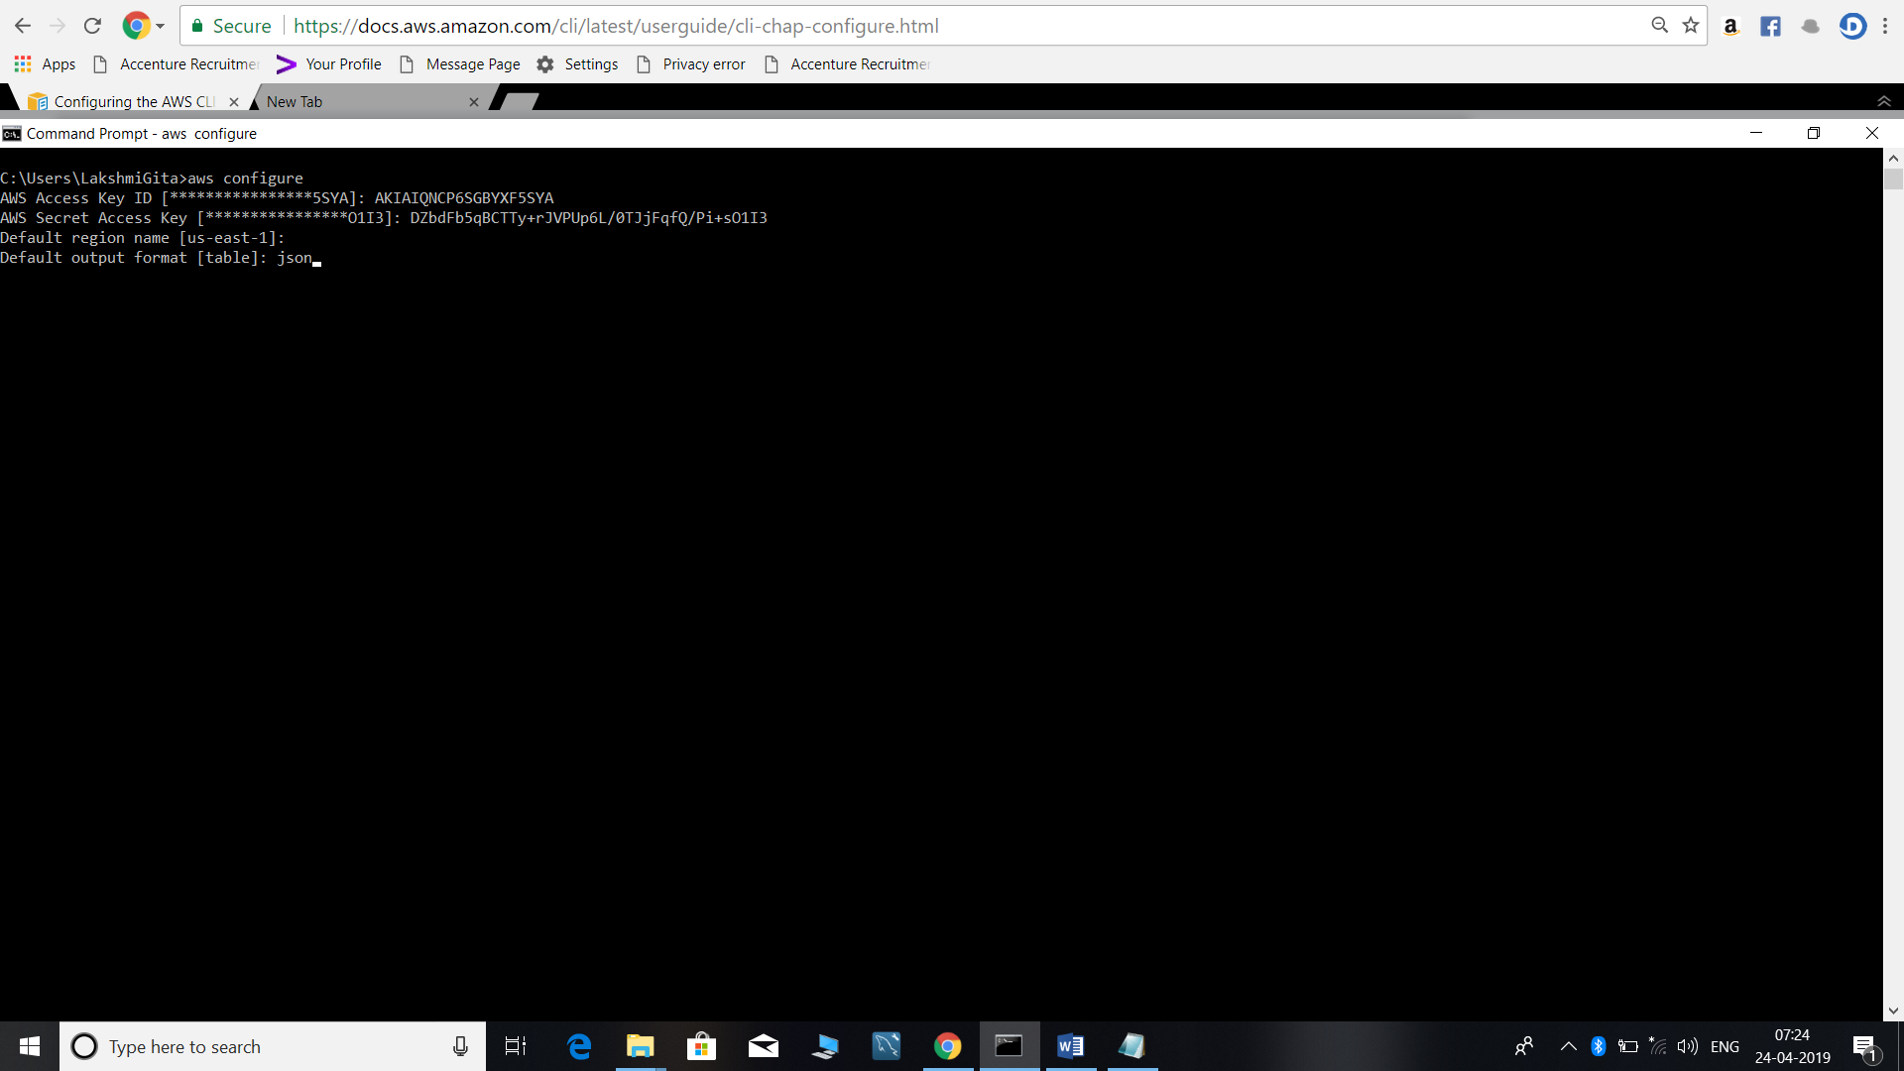

To get the EC2 List in your region

* aws ec2 describe-instances

**22-april-2091 Notes**

You can enable MFA on root account

Security States

IAM Principal Pal /IAM Policies

1. IAM Users
2. IAM Groups
3. IAM Roles

S3 Bucket Policy

Policies are there types

1. AWS Managed Policy
2. Customized Policy
3. Inline Policy
4. User =🡺 Inline Policy Provides security

IAM Roles applied in Security Groups

An IAM Role can be attached EC2 instance

**29th and 01-May-2019 Route 53 Notes**

Amazon Route 53 is a highly available and scalable Domain Name System (DNS) web service. You can use Route 53 to perform three main functions in any combination: domain registration, DNS routing, and health checking. If you choose to use Route 53 for all three functions, perform the steps in this order:

<https://docs.aws.amazon.com/Route53/latest/DeveloperGuide/Welcome.html>

* Route 53 service – PUBLIC DNS (Domain Name Service)
* Buy a domain (GODADDY.COM)
* You can buy or transfer domain in Route 53 also
* For a meaning full website (customization name).like example google.com or kellyaws.com

1. Buy a domain
2. Monitor (URL)
3. Hosted zone
4. Traffic Manager (Policy)

* Subdomains for main domain
* Transfer Domain from GODADDY also
* Route 53 present in Global Region
* Hosted zones
* Private hosted zone for Amazon VPC
* https: SSL
* SSL wild Card Certification (*.kellyaws.com)
* Certificate Manager in AWS
* AWS🡺 Route 53 Hosted zone Alias
* Bucket Name and Alias Name should be same in S3 hosted zone
* Server less architecture
* ELB (Elastic Load Balancing) – Region is not working
* Routing Policy (weighted, simple, latency, Failover, GeoLocation ,MultiValueAnswer
* Weighted can be used when upgrade of website is going on It will maintain the loads in ratios
* HealthChecks will check the website is working or not (Health check in multiple regions).
* Checks in end points.
* FreeNom.com – for registering the domains.

**03-May-2019 Lamda functions**

(Development Service) Server less architecture (FAAS)

Framework as Service

Schedule vs Event

Events stop EC2 instances (Cloud watch) -🡪 Stop EC2 instances

Lamda Functions (Schedular and Event).

18-May-2019 – AWS Trusted Advsior DashBoard- AWS Service.